2015 WITESOL Conference

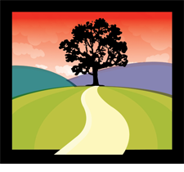

Cultural Journeys through

Language and Learning



October 24, 2015

University of Wisconsin - Oshkosh

Reeve Memorial Union

Welcome to the 2015

WITESOL Conference!

We would appreciate your comments. Please fill out the evaluation at the end of this program and return it. Also, if you would be interested in participating on the WITESOL Board, please contact one of our board members for more information. Visit www.witesol.com for contact information.

WITESOL Board Members
President Lori Menning, School District of New London, Silver Lake College
President Elect
Past President Melanie Schneider, UW-Whitewater
Treasurer Maureen Garry, Milwaukee Area Technical College (retired)
Secretary Rhonda Petree, UW-River Falls
Membership Sheryl Slocum, Alverno College
Members-at-Large Tim Dalby, UW-Madison
Don Hones, UW-Oshkosh
Kari Johnson, School District of Fort Atkinson
Anjie Kokan, Whitewater Unified School District, UW-Whitewater
Committee Chairs:
Advocacy Lori Menning
Marketing/Newsletter Johnna Knoke
Proposal Review Rhonda Petree
TESOL Complimentary
Membership Awards Sheryl Slocum
TESOL Travel Awards M. Maureen Garry
Webpage & Social Media Kari Johnson
Writing & Art Contest Anjie Kokan

Acknowledgements

Session Presenters
Thank you for volunteering to share your knowledge and expertise in order to make this conference a success. We are privileged to work with and learn from you.

UW-Oshkosh and Other Co-sponsors for Sonia Nazario Events at WITESOL and on Campus:

Project Estrella, College of Education and Human Services

Department of English and Department of Foreign Language and Literature

Inter Tribal Student Organization (ITSO)

Reeve Union Diversity and Inclusion Programs

Social Justice

Student Organization of Latinos (SOL)

School District of New London

WITESOL
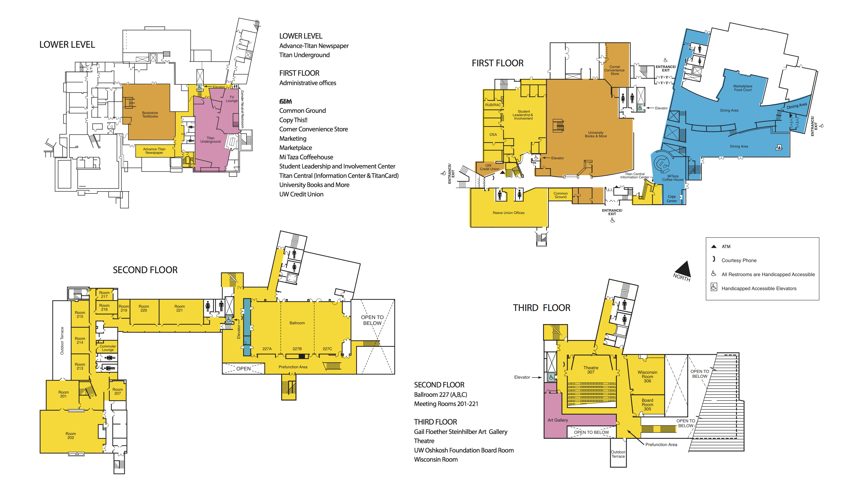
Reeve Memorial Union

Conference Agenda at-a-Glance

Reeve Ballroom (2nd floor), Room 227, is the location for the keynote speaker, lunch, and publishers/vendors.
8:00 – 9:00 a.m. Registration & Continental Breakfast
9:00 – 9:15 a.m. Welcome
9:15 – 10:15 a.m. Keynote Speaker
10:15 – 10:30 a.m. Exhibitor Break
10:30– 11:15 a.m. Concurrent Session 1
11:15 – 12:00 p.m. Concurrent Session 2
12:15– 1:30 p.m. Lunch and Annual WITESOL Meeting
1:30 – 2:15 p.m. Concurrent Session 3
2:15 – 2:30 p.m. Exhibitor Break and Snack
2:30 – 3:15 p.m. Concurrent Session 4
3:15 p.m. Door Prize Drawing
For updates visit WITESOL anytime/anyplace:

Visit our website: www.witesol.com

Like us on Facebook: WITESOL Facebook Page

Follow us on Twitter: @WITESOL

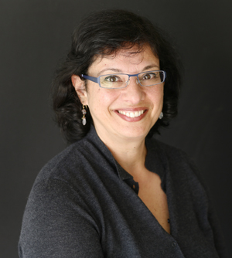

Sonia Nazario, Author of Enrique’s Journey

Sonia Nazario is an award‐winning journalist whose stories have tackled some of this country’s most intractable problems–hunger, drug addiction, immigration–and have won some of the most prestigious journalism and book awards.

She is best known for Enrique's Journey, her story of a Honduran boy’s struggle to find his mother in the U.S. Published as a series in the Los Angeles Times, Enrique's Journey won the Pulitzer Prize for feature writing in 2003. It was turned into a book by Random House and became a national bestseller.

Her recent humanitarian efforts to get lawyers for unaccompanied migrant children led to her selection as the 2015 Don and Arvonne Fraser Human Rights Award recipient by the Advocates for Human Rights. She was also named a 2015 Champion of Children by First Focus and a 2015 Golden Door award winner by HIAS Pennsylvania.

Nazario, who grew up in Kansas and in Argentina, has written extensively from Latin America and about Latinos in the United States. She has been named among the most influential Latinos by Hispanic Business Magazine and a “trendsetter” by Hispanic Magazine. In 2012 Columbia Journalism Review named Nazario among “40 women who changed the media business in the past 40.”

She is a graduate of Williams College and has a master’s degree in Latin American studies from the University of California, Berkeley. She has honorary doctorates from Mount St. Mary’s College and Whittier College. She began her career at the Wall Street Journal, and later joined the Los Angeles Times. She is now at work on her second book.
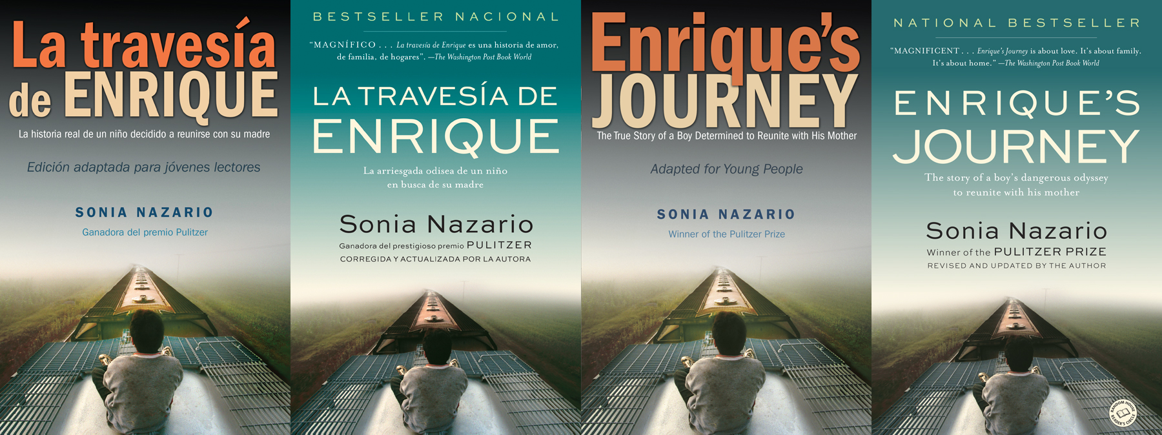

Keynote Speaker 9:15-10:15 a.m. Sonia Nazario, Ballroom 227

Concurrent Session I 10:30-11:15 a.m.
Title: Using Enrique’s Journey in the Classroom  Audience: All  Session Type: Practice  Content: Classroom Practices  Abstract: Are you considering incorporating the book Enrique’s Journey into your classes? In this session Sonia will share a variety of resources to use in planning and instruction. Lori will highlight the professional learning community she formed at her high school which had over 500 students reading the book and/or related articles. | Presenters: Sonia Nazario, with Lori Menning, School District of New London, Silver Lake College  Room: Reeve Ballroom 227
Title: Transitioning Students with Refugees Backgrounds (SRBs) into Schools – Part 1  Audience: All  Session Type: Practice & Panel  Content: Teacher Education  Notes: (Double Session)  Abstract: This 2-part series will begin with a practice-oriented presentation (45 minutes), followed by a panel discussion and activities (45 minutes) that highlight steps one school district has taken to support the transition of students with refugee backgrounds (SRBs). Content includes grants, processes, and the vital roles that K12 ELL Specialists play in the transition. | Presenters: Dawn Shimura, District ELL Coordinator, Oshkosh Area School District  Fran Caruana, K12 Refugee Liaison, Oshkosh Area School District  Margo Goff, ELL Specialist, Oshkosh Area School District  Amy Moua, ELL Specialist, Oshkosh Area School District  Room: 201
Title: Project COMPASS: Practices and Challenges for Promoting Co-Teaching  Audience: All  Session Type: Practice  Content: Classroom practices  Abstract: Project COMPASS is an initiative to promote co-teaching practices in the Fox Valley and beyond. Participants in this session will address the rationale for co-teaching, how to build a team of committed ELL and regular education teachers as well as administrators, key practices, potential benefits and ongoing challenges. | Presenters: Donald Hones, UW Oshkosh  Gretchen Lettau, ELL/Bilingual Diversity Coordinator, Menasha Joint School District  Room: 214

Title: What do Good Readers Do? Exploring Parent/Child Reading Instruction  Audience: Adult  Session Type: Practice  Content: Materials development  Abstract: Difficulty decoding text disheartens and excludes beginning readers from their peers. Often, it is not only the student experiencing these feelings. This session demonstrates a curriculum adaptable for number of sessions that provides basic comprehension and critical thinking, empowering illiterate parents to read with their children. | Presenter: Erin Conway, Program Manager, The Literacy Connection  Room: 220

Title 1: Homework for Language Learners: A Necessary Evil?  Title 2: Paving the Path for Arabic L1 Speakers  Note: Two 20-minute research presentations  Audience: Secondary/All  Session Type: Research presentation  Content: Classroom-based research/Second lang. acquisition  Abstract 1: This session is based on an action research study of the effects of homework on the academic achievement of ELLS in middle school. ELLs face many obstacles to homework completion, yet there are ways to improve their outcomes. We'll explore the good, the bad, and the ugly regarding homework and ELLs.  Abstract 2: This presentation will alert ESL instructors to unique Arabic L1 challenges, including common syntactical errors due to L1 transfer and Arabic language rhetorical devices that transfer to L2 English. Arab cultural factors that may influence English L2 acquisition will also be discussed. | Presenter 1: Kaycee Rogers, ELL Teacher, School District of the Menomonie Area  Presenter 2: Lora Beseler  Room: 221

Concurrent Session II 11:15-12:00 p.m.

Title: Transitioning Students with Refugees Backgrounds (SRBs) into Schools – Part 2  Audience: All  Session Type: Practice & Panel  Content: Teacher Education  Notes: (Double Session)  Abstract: This 2-part series will begin with a practice-oriented presentation (45 minutes), followed by a panel discussion and activities (45 minutes) that highlight steps one school district has taken to support the transition of students with refugee backgrounds (SRBs). Content includes grants, processes, and the vital roles that K12 ELL Specialists play in the transition. | Presenters: Dawn Shimura, District ELL Coordinator, Oshkosh Area School District  Fran Caruana, K12 Refugee Liaison, Oshkosh Area School District  Margo Goff, ELL Specialist, Oshkosh Area School District  Amy Moua, ELL Specialist, Oshkosh Area School District  Room: 201

Title: Optimizing Experiential Learning: Personalized Place-based Activity Planning  Audience: Higher Education  Session Type: Practice  Content: Materials development  Abstract: A crash course in baseball, a Mississippi river road trip, a visit to the county fair—these were units in an experiential learning course created for BSMP students during a summer program. This presentation will provide background, an overview of the course, and considerations for designing a similar experience. | Presenters: Sam Herrington, UW-River Falls  Conan Kmiecik, International Student Services Coordinator, UW-River Falls  Room: 214

Title: What Every Immigrant Needs to Know, but May Not Ask  Audience: Adult  Session Type: Practice  Content: Second language acquisition  Abstract: This interactive workshop will span the scope of cultural knowledge a newcomer to the U.S. needs to succeed. A wide range of topics will be covered to showcase what new arrivals need. This session will model effective ways to share cultural literacy with the adult learners in your program. | Presenter: Trena Anderson, SW Regional Consultant, Wisconsin Literacy  Room: 215

Title: Promoting Inquiry and Literacy with Science Notebooks in Dual-Language Classrooms  Audience: Elem  Session Type: Practice  Content: Classroom practices  Abstract: This presentation offers two perspectives on the use of science notebooks by second grade dual-language learners: 1) a general perspective on how they can be used to integrate science and literacy learning and 2) specific classroom examples of how science notebooks were used and what they show about student learning. | Presenters: Melanie Schneider, UW-Whitewater  Elizabeth Fontán, Dual Language Teacher, School District of Beloit  Room: 220

Title: Grammar Drill or Delight? Materials Evaluation from a Teachers’ Perspective  Audience: Adult  Session Type: Practice  Content: Materials development  Abstract: Grammar Instruction should be ‘socially dynamic’. However, TESOL oscillates between descriptive and prescriptive approaches. This paper evaluates an ESL–EAP University instructional materials package for its ‘presentation’ and ‘performance’: content, design and methodology. Both communicative and isolated practices are identified. Teachers’ evaluation leads to stewarding the curriculum and developing professionally. | Presenters: Amitha Gone, ESL Instructor, Milwaukee School of Engineering  Joe Volkert, ESL Instructor, Milwaukee School of Engineering  Room: 221

Concurrent Session III 1:30-2:15 p.m.

Title: What’s It All About?  Audience: All  Session Type: Practice  Content: Classroom practices  Abstract: Many districts have seen increases in English learner enrollment. This presentation provides a Title III program overview and addresses specific program elements beneficial to educators new to serving ELs or who need a refresher. Attendees will be able to think holistically about how this program enhances support for students they serve. | Presenter: Audrey Lesondak, ESL/Bilingual Education Consultant, Wisconsin Department of Public Instruction  Room: 201

Title: Using Main Street as a Text in an American Culture Course  Audience: Higher  Session Type: Practice  Content: Materials development  Abstract: Teaching American culture to international students in a summer program can be daunting. How do you teach them sufficiently about life in the United States in 2-4 weeks? This session will introduce one way an American culture course was successfully taught in a short-term summer program. | Presenters: Kiki Augustin, UW-River Falls  Conan Kmiecik, International Student Services Coordinator, UW-River Falls  Room: 214

Title: Launch for Language Learning  Audience: Elementary  Session Type: Practice  Content: Classroom Practices  Abstract: Learn how to engage students actively in learning new vocabulary and concepts through multisensory activities, activating prior knowledge, and direct vocabulary instruction all wrapped up into a dynamic Launch for Language Learning! | Presenter: Mikaely Schmitz, Speech Language Pathologist, ESL, Milwaukee Public Schools  Room: 215

Title: Storytelling? Spinning Yarns For Second Language Acquisition  Audience: All  Session Type: Practice  Content: Classroom practices  Abstract: Storytelling empowers teachers and learners alike in the learning process. Telling stories and teaching students to tell stories will increase vocabulary, enhance listening, speaking, reading and writing skills, spark imagination and visualization, and help students understand their cultural heritage and those of others. | Presenter: Kay Elmsley Weeden, Owner, Kaytales  Room: 220

Title: Assessment of an Evolving EAP Program: Strategies for Evaluation  Audience: Adult  Session Type: Practice  Content: Assessment  Abstract: Success of language programs depends on ongoing, multi-faceted evaluation. This paper provides insight into strategies employed in the evaluation of an evolving EAP program. The program is examined multi-dimensionally; successes are credited to the rigorous nature of the program, its design and assessment procedures, and ongoing professional development. | Presenters: Katherine Vernezze, Coordinator of ESL, Milwaukee School of Engineering  Allison Heine de Romero, EAP Instructor, Milwaukee School of Engineering  Room: 221
Concurrent Session IV 2:30-3:15 p.m.

Title: Journey to Finding our Voices: Advocacy Skills for ELL Teachers  Audience: All  Session Type: Practice  Content: Teacher Education  Abstract: All teachers of ELLs need to be skilled advocates for their students but may struggle in the journey to find their voice. In this session, the presenter first identifies skills used by experienced ELL teacher-advocates, and then demonstrates several activities to develop these skills in all teachers working with ELLs. | Presenter: Heather Linville, Director of TESOL, UW-La Crosse  Room: 201

Title: Planning Authentic Learning Experiences through Campus and Community Involvement  Audience: All  Session Type: Panel  Content: Classroom practices  Abstract: In this session, participants will gain information from panelists about the integration of campus and community involvement that enhances language learning in meaningful, real-life contexts. Attendees will walk away with new ideas about how they can plan similar collaborations. | Presenters: Susan Huss-Lederman, UW-Whitewater  Ellen Boldt, UW-Whitewater  Brianna Deering, UW-Whitewater  Haline Ferreira, UW-Whitewater  Rossitza Ivanova, UW-Whitewater  Anjie Kokan, Whitewater Unified School District, UW-Whitewater  Karen Wislocky, Independent Academic  Room: 214

Title: Co-teaching in Action  Audience: All  Session Type: Practice  Content: Classroom Practices  Abstract: This hands-on presentation will explore different models of co-teaching and provide opportunities to put them into practice. Participants will feel confident and excited about implementing these co-teaching models. Set your English Language Learners up for success! | Presenters: Brittany Schmidt, K-4 Bilingual/ELL Teacher, School District of New London  Jen Cardinal, School District of New London  Room: 215

Title: Sharing Cultural Journeys and Other Stories with Technology  Audience: All  Session Type: Practice  Content: Educational technology  Abstract: Learn how to incorporate technology into your classroom and get students excited to write and share their own personal stories. You will learn about free digital storytelling resources and how to use them with students. Examples of digital stories from ELL students will be shared to deepen your understanding. | Presenter: Kari Johnson, ELL Teacher, School District of Fort Atkinson  Room: 220

Title: Measuring Students’ Grammatical Complexity: How and Why?  Audience: Higher  Session Type: Practice  Content: Classroom-based research  Abstract: This presentation describes three simple methods of measuring grammatical complexity in student writing. A study of a small set of compositions demonstrates the results of the measures and allows for discussion of the usefulness of the different measures and implications for teaching and research. | Presenter: Sheryl Slocum, ESL Coordinator, Alverno College  Room: 221

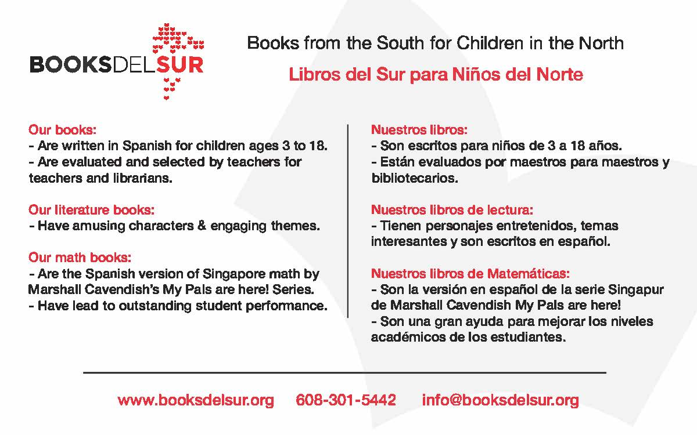

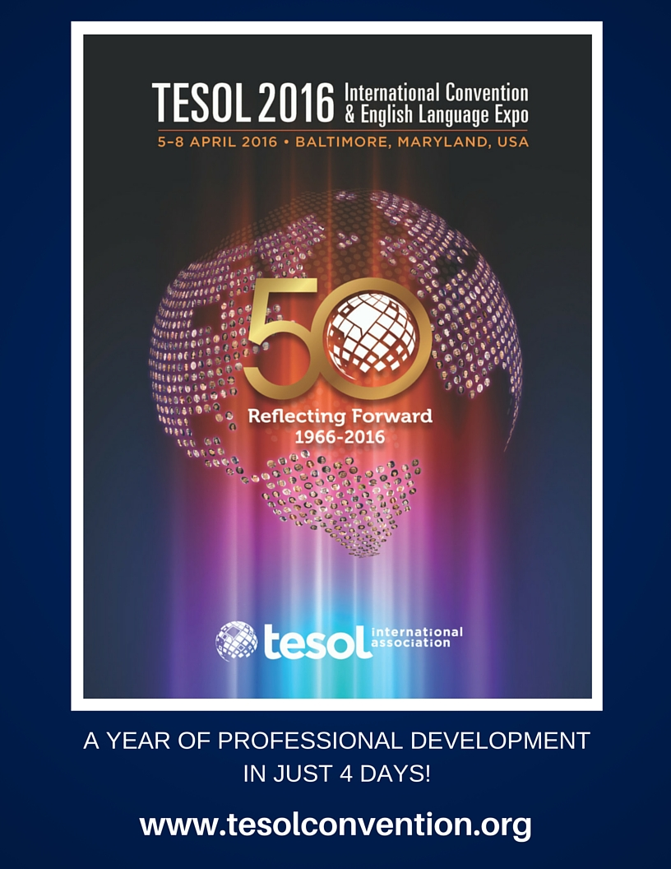

Exhibitors

Be sure to visit our exhibitors to learn about a variety of educational materials:

Benchmark Education
Books del Sur
Imagine Learning
Intercambio Uniting Communities
National Geographic Learning/Cengage Learning
School Specialty
University of Wisconsin-River Falls
Wisconsin Media Lab

WITESOL is a proud affiliate of TESOL International:
www.tesol.org

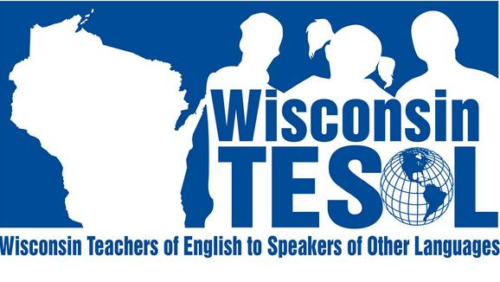

BENEFITS of WITESOL Membership
- Attend WITESOL training sessions or workshops exclusively for WITESOL members
- Reduced registration rate and costs for attending the TESOL International Convention
- Email updates exclusively for WITESOL members with information about job openings, conferences, training sessions, workshops, and more
- Support and expertise of other ELL and bilingual educators in Wisconsin
- Participation in the annual WITESOL Student Writing and Art Contest
- Apply for travel awards to attend the TESOL International Convention

Stay connected with us for details!

 www.witesol.com


WITESOL Facebook Page


@WITESOL

Contact us with questions: witesolboard@gmail.com

2015 WITESOL Conference Evaluation October 24, 2015

Name (optional): ________________________________ Position: __________________________

District/Organization/IHE: ________________________________ Grade Level: _______________

**Your 2015 Conference Registration includes WITESOL membership for one year. Please contact a WITESOL Board Member today or provide the following information if you would like to be contacted about any of the following WITESOL opportunities.**

Email: _______________________________________ Phone: _______________________________

Check if you are interested in:
_____becoming a WITESOL Newsletter Editor
_____becoming a WITESOL Board Member
_____presenting at a future WITESOL conference or other event

Circle the appropriate response (1=Poor, 5=Excellent)
1. Keynote Address

- Quality of information 1 2 3 4 5
- Relevance of information 1 2 3 4 5
- Presenter knowledgeable about subject 1 2 3 4

2. Concurrent Session 1 (list session title or presenter(s):__________________________________

- Quality of information 1 2 3 4 5
- Relevance of information 1 2 3 4 5
- Presenter knowledgeable about subject 1 2 3 4 5

3. Concurrent Session 2 (list session title or presenter(s):___________________________________

- Quality of information 1 2 3 4 5
- Relevance of information 1 2 3 4 5
- Presenter knowledgeable about subject 1 2 3 4 5

4. Concurrent Session 3 (list session title or presenter(s):___________________________________

- Quality of information 1 2 3 4 5
- Relevance of information 1 2 3 4 5
- Presenter knowledgeable about subject 1 2 3 4 5

5. Concurrent Session 4 (list session title or presenter(s):___________________________________

- Quality of information 1 2 3 4 5
- Relevance of information 1 2 3 4 5
- Presenter knowledgeable about subject 1 2 3 4 5

Comments:

This conference provided me the opportunity to:

At future conferences, it would be beneficial to:

